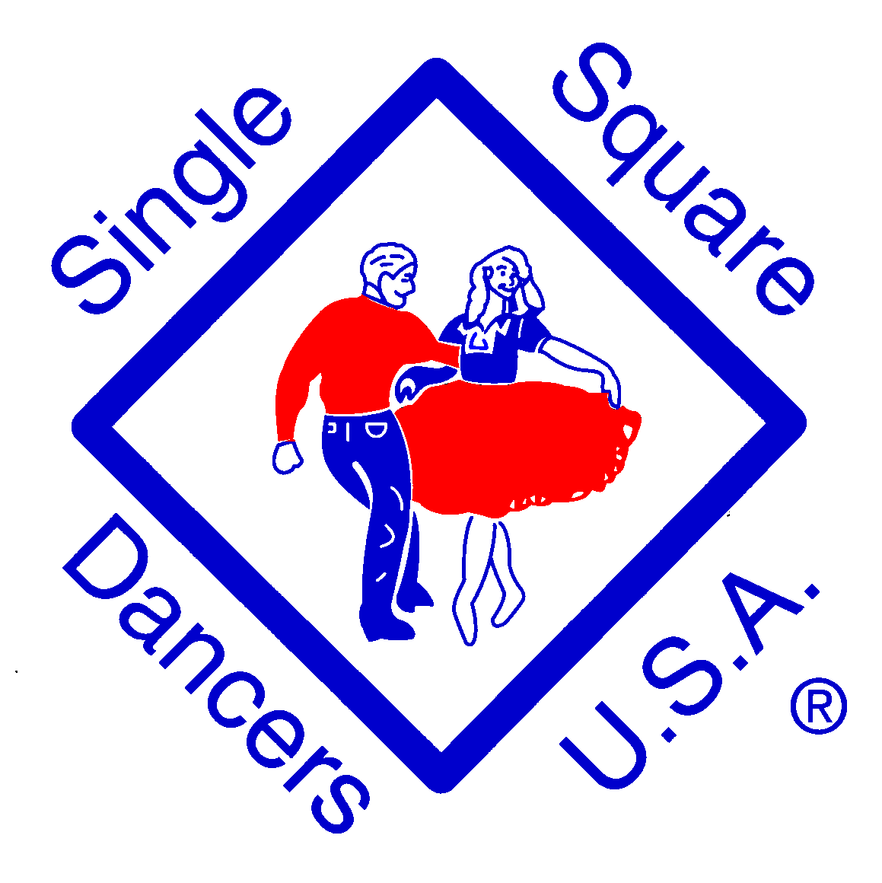

SINGLE SQUARE DANCERS U.S.A.

Yellowrock Caller/Cuer Scholarship

Single Square Dancers U.S.A. will be selecting the winner(s) of the Frank Norris Yellowrock Scholarship during our next annual Single’s Dance-A-Rama, which will be held on Labor Day weekend. To qualify the winner need not be single, a member of Single Square Dancers U.S.A., or present at the Dance-A-Rama, to win.

The caller or cuer must be at least 12 years old (before September 1 of the current year) and have no more than three years of regular calling or cueing experience. Along with a completed application form, applicants must send a demo CD or link to YouTube. For callers this needs to demonstrate performance of one singing call and approximately two minutes of “patter” calling. For cuers, the demo CD or link to YouTube needs to demonstrate two rhythms (waltz, two step, fox trot, etc.).

The Yellowrock Scholarship Application is on the reverse side of this flyer. Please send the complete packet. Include a self addressed, stamped, envelope for use in acknowledging the receipt of the packet. Please send to the following address:
Velma Doyle
SSDUSA Scholarship Award
3938 Crestfield Drive
Groveport, OH 43125
Phone: (614) 837-6974
E-mail: velmadoyle@sbcglobal.net

THE DEADLINE FOR RECEIPT OF COMPLETED PACKET IS: August 1st.

For information on Single Square Dancers U.S.A. please visit the web site at www.ssdusa.org or email the club at info@ssdusa.org.

SINGLE SQUARE DANCERS U.S.A.

Yellowrock Caller/Cuer Scholarship Application

Name ____________________________ Age _____ Sex: Male □ Female □

Street Address ________________________________________________________

City _____________________________________ State__________ Zip __________

Home Phone _______________________ Email Address ______________________

Caller □ Cuer □ Years Calling/Cueing _______ (must be less than 3 years)

Club Affiliation __________________________________

Brief Biography:

For Official Use Only

Assigned No: __________ Date Received: __________

